The Mighty Creatives

Cultural Education Partnerships
Arts Award Start-up and Progression Packages (SUP)

Application Form 2020-2021

Name:

Organisation name:
Address:

Email:
Phone:
What Cultural Education Partnership (CEP) are you a partner of?  Please note, before we award a Start Up package, we will check with the relevant CEP that you are partner. | DCEP (Derbyshire CEP)  UNLOCK (Northants)  The City Classroom (Leicester/shire CEP)  Chesterfield CEP  Lincolnshire CEP  Black Shale (Amber Valley and Bolsover CEP)  ChalleNGe (Nottingham CEP)  Captivate (Ashfield and Mansfield CEP)
What type of package are you applying for: | Start-up Package  Progression Package
Which level will you be delivering at: | Discover Bronze  Explore Silver
Please tick here to say you have had your pre-application phone call with TMC (Laura Bates or Kevin Tennant for Cultural Education Partnership applications):

If you are a school, are you currently registered as Artsmark? | Yes / No
Dates of delivery: | Please note the moderation deadline has been extended by a quarter from Friday 12th March 2021, to Tuesday 30th June 2021.  Start date:  End date:
Please add the number of young people who will take part in the Arts Award delivery:
__ 5 – 11 Years __ 12 – 16 Years __ 17 and 18 Years __ 19 + Years

__ Total number of young people involved

How many young people will complete an Arts Award? And what level? (Please number each appropriate Level. Please note these figure will be included in your grant agreement with TMC)

Level | No. of young people
Discover
Explore
Bronze
Silver
Gold

What geographical area does the project cover?
Leicestershire Nottinghamshire Derbyshire Northamptonshire Lincolnshire Rutland

- Have you been funded previously by The Mighty Creatives? If so, please provide details of when and for what.

- Please give us a brief overview of what your organisation/School does and the young people you work with:

- Tell us how you will implement Arts Award in your setting – maximum 500 words
Please ensure your answer refers to:
- Quality delivery of Arts Award
- Impact of delivering Arts Award on the young people you work with and your organisation
- Ambition around delivering the award
- Timescale of delivering your chosen level

- Tell us how you will explore the themes of the Environment and Sustainability and/or the Digital. – maximum 350 words

- Please tell us about your plans for next steps and future delivery. How might this grant help embed/sustain Arts Award and how could it inform/help your future work?

Please provide an outline of how you anticipate you will spend your grant of £750 below (please ensure you have included moderation costs and any materials you wish to purchase):

Product | Amount
Total: | £

Signed:
Name:
Date:

Important dates for your calendar:

Due to the current situation, the training dates below are to be postponed until September. The deadline for delivery and moderation is to be extended by a quarter to 30th June.

Adviser Training Dates:
- Tuesday 2nd June 2020- Bronze and Silver training (full-day training followed by a twilight mapping and planning session) – Leicester (postponed until September, date tbc)
- Tuesday 2nd June 2020- Discover and Explore Training (half-day training followed by afternoon mapping and planning session) – Leicester (postponed until September, date tbc)

Mid-point meeting:
- Wednesday 4th November 2020: Twilight mid-point meeting – Nottingham

Pre-moderation session:
- Tuesday 12th January 2021: Pre-moderation session – Nottingham

Final report:
- Friday 19th February 2021: Final report evaluation

Moderation deadline:
- Friday 12th March 2021 (Extended to Tuesday 30th June 2021)

Please tick this box to say you have made a note of these dates and can attend the relevant training

Deadline for Applications is Monday 4th May 2020 at 5pm

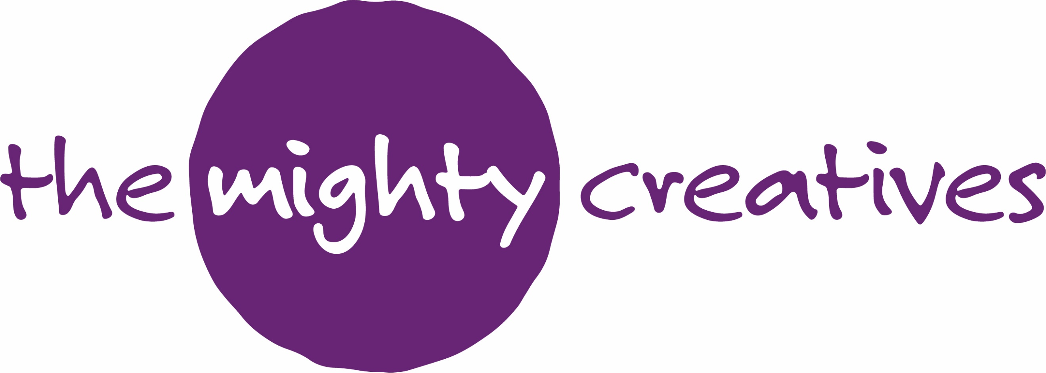
We want to stay in touch…
We like to keep in contact with the individuals and organisations we connect with, this helps us grow as a charity and improve our work for children and young people.
Our marketing is predominantly informative and not excessive, however, should you wish to adjust the frequency of our contact with you, you can do so at any time.

The data you provide will be retained by The Mighty Creatives (the ‘data holders’) in accordance with the provisions of the Data Protection Act 1998 and related legislation. By providing your data to us, you are consenting to the data holders making contact with you in the future by telephone, email or other means. Your data will not be sold and will not be given to anyone not connected to The Mighty Creatives.

If you would like more information about our data protection policy, please visit our terms and conditions pages on our website.

I give permission for The Mighty Creatives to contact me with future details and opportunities

(Name)…………………………………………………………………………………. (Date)…………………………………………………………..

Once complete please email your application to: ArtsAlliances@themightycreatives.com

