Risk Assessment Template

Assessment No: | Location: | Further assessments required:  (please attach as Appendix)  Fire  COSHH  Manual Handling  Display Screen Equipment | Persons involved in or affected by the task:  Employees  Visitors  Funders  Members of the public  Participants  Others | Special Groups: (Where additional assessments may be required)  Nursing and Expectant Mothers  Young Persons  Disabled
Assessment Date: | Assessor's Name:
Individual/group:
(Give numbers)
Activity and Areas assessed:

Key Staff:

Hazards Identified | Potential severity of harm | Current Control Measures in Place | Likelihood of harm occurring | Score | Rating

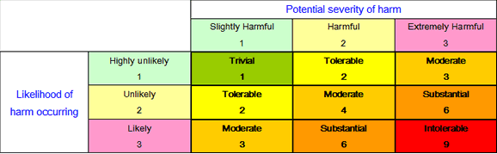

Action required (note any temporary action / control measures required): | Action Review Date |  | Action Completed (Name and title) / Date
If any issues are outstanding from the 'Action Review' date, detail the reasons:

Signature: |  | Date:

